EASTERN INTERNATIONAL UNIVERSITY
Becamex Business School — MIS 443: Business Data Management
Schedule Analytics: A Star-Schema Data Warehouse and SQL-Based Workload Analysis for University Timetable Management
Course Project — Option: Lecturer-Provided Dataset

Đặng Huỳnh Quỳnh Như
IRN 2032300287
Business Analytics Program
Quarter 1, Academic Year 2025–2026
Repository: github.com/NhuqDangg/MIS-443---Business-Data-Management

Abstract
University registrars typically maintain class timetables as a single flat spreadsheet, a format that is easy to produce but difficult to query: cells routinely encode more than one fact at once (e.g., a Day field of "MR" or a Period field spanning two non-contiguous date ranges), and the sheet cannot directly answer operational questions such as which instructors are overloaded, which rooms are underused, or whether any two sections have been double-booked. This project transforms one such spreadsheet — the Quarter 1, 2025–2026 timetable of a Vietnamese university — into a nine-table PostgreSQL star schema (five dimensions, one primary fact, two bridge tables, and one session-level fact), validated the load with row-count and hour-total cross-checks, and used SQL aggregation, grouped analysis, and self-joins to surface four operational insights: a workload-illusion effect where class count and total teaching hours rank instructors differently; a distinction between chronic and episodic instructor overload visible only at weekly granularity; an uneven distribution of room utilization across campus buildings; and a directly detected instructor double-booking. The analysis is also exposed as a live, non-technical dashboard built with Google Apps Script. The results support three concrete recommendations for the registrar's office: enforce weekly teaching-hour caps with early warning at peak weeks, rebalance lecture sections away from the most heavily used building, and run the double-booking and credit-hour checks as automated database views before, not after, a timetable is published.

1. Introduction
Timetabling data sits at the intersection of academic operations and data management: it is produced every term, touches every instructor and room on campus, and is almost always stored as a flat table optimized for human reading rather than for querying. The specific dataset behind this project — a Quarter 1, 2025–2026 class schedule — exhibits two structural problems common to spreadsheet-native data. First, it violates First Normal Form (1NF) in two columns: the Day column encodes multiple weekdays in a single cell (e.g., "MR" for Monday and Thursday), and the Period column occasionally encodes two non-contiguous date ranges in a single cell (e.g., "06/10-29/11 ; 08/12-13/12"). Second, even once read correctly, the flat format cannot answer operational questions — who is overloaded, which room sits empty, whether two classes overlap — without extensive manual cross-referencing.
This project addresses both problems by re-modeling the timetable as a relational star schema in PostgreSQL and using SQL to answer those operational questions directly, then exposing the results through both a version-controlled GitHub repository (raw data, schema, and queries) and a live web dashboard for non-technical stakeholders such as the registrar's office.

2. Project Objectives
In line with the course's project objectives, this work aims to:
- Design and implement a structured relational database to store and manage a real, lecturer-provided institutional dataset using SQL.
- Clean and transform the raw spreadsheet — specifically, resolve its two 1NF violations — into a normalized, queryable schema.
- Conduct exploratory data analysis to identify workload, resource-utilization, and scheduling-conflict patterns.
- Translate the analytical results into concrete, actionable recommendations for the registrar's office.
- Make the full pipeline reproducible and publicly documented, so that any reader can import the same data and re-run the same analysis.

3. Scope and Methodology
The course brief frames this project around four tasks — data acquisition, database design, preprocessing, and exploratory/analytical work. Table 1 maps each task to how it was addressed in this project, including one deliberate adaptation explained in Section 3.4.
Table 1. Mapping of assignment tasks to project deliverables.
Assignment task | How this project addresses it
1. Data acquisition | Lecturer-provided dataset (registrar's Q1 2025–2026 timetable, Excel) — used under the assignment's "Other: dataset from lecturer" option, in place of web crawling. Source and scope documented in Section 3.1.
2. Database design & storage | Nine-table PostgreSQL star schema (5 dimensions, 1 fact, 2 bridge tables, 1 session-level fact), implemented with DDL, constraints, indexes and views. Section 3.2.
3. Data preprocessing | Resolved two 1NF violations in the source sheet (multi-value Day and Period cells) via dedicated bridge tables; validated row counts and hour totals after load. Section 3.3.
4. Exploratory & analytical work | SQL-based EDA (aggregation, self-joins, two-step grouped averages) plus a live Google Apps Script dashboard for visual exploration. Text-based techniques (sentiment analysis, topic modeling) do not apply, since the dataset is structured scheduling data rather than review or comment text — see Section 3.4 for this adaptation. Sections 4–5.

3.1 Data Source
The dataset was provided directly by the institution rather than crawled from the public web, consistent with the assignment's alternative data-source option ("dataset from lecturer provide"). The source file is a single Excel workbook containing the Quarter 1, 2025–2026 class schedule: 216 scheduling records covering 74 instructors, 114 courses, 141 class sections, and 36 physical rooms across six campus buildings. Using an institutionally issued dataset removes web-crawling concerns (rate limiting, terms-of-service compliance, HTML parsing) but introduces a different first challenge: the sheet was authored for human reading, not machine querying, and required structural cleanup before it could support SQL analysis.

3.2 Database Design and Storage
The cleaned data was modeled as a star schema in PostgreSQL 14, organized around a central fact table (fact_schedule) representing one instructor teaching one recurring weekly time block. Table 2 summarizes the nine tables in the schema.
Table 2. Star schema: dimension, fact, and bridge tables.
Table | Grain | Rows | Primary key
dim_instructor | One instructor | 74 | instructor_code
dim_room | One room | 36 | room_id
dim_course | One course | 114 | course_code
dim_date | One calendar date | 69 | date_id
dim_class | One class section (course × CRN) | 141 | class_code
fact_schedule | One instructor × one recurring time block | 216 | schedule_id
schedule_period | Bridge — splits multi-date-range cells | 233 | period_id
schedule_day | Bridge — splits multi-day-code cells | 363 | (schedule_id, day_code)
fact_session | One class meeting on one specific date | 2,697 | session_id
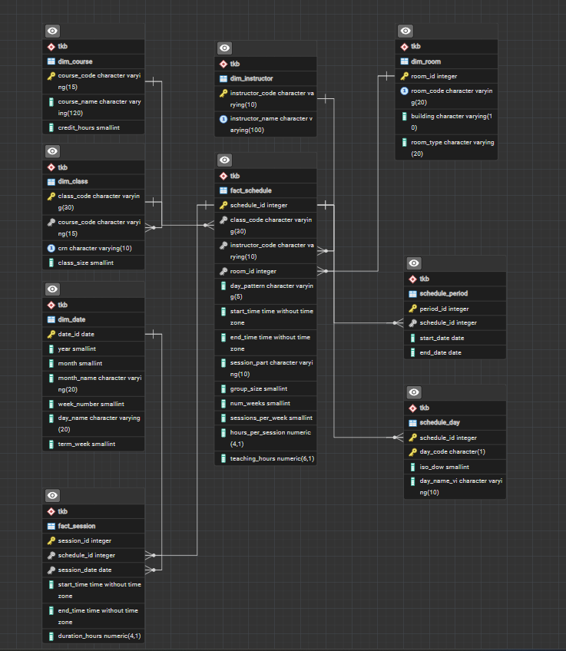
Figure 2.1. Entity-Relationship Diagram showing primary keys (gold), foreign keys (arrows), and the relationships between five dimensions, two bridge tables, and two fact tables.
Two design decisions are worth noting. First, dim_class and dim_instructor use natural, human-readable keys (e.g., class_code = "BUS 332 - 01", instructor_code = "GV_17") rather than opaque surrogate integers, which keeps ad hoc debugging queries readable without extra joins. Second, referential integrity is enforced throughout with foreign keys and CHECK constraints — for example, fact_schedule.teaching_hours is constrained to equal num_weeks × sessions_per_week × hours_per_session, so a data-entry error cannot silently produce an inconsistent hour total. The ERD (Figure 2.1) visualizes the relationships: five dimensions (dim_course, dim_instructor, dim_room, dim_date, dim_class) feed into the core fact table fact_schedule; two bridge tables (schedule_period and schedule_day) resolve 1NF violations; and a derived fact table fact_session denormalizes the many-to-many relationships into a session-level grain suitable for time-series and conflict analysis.
Core data management operations (INSERT via CSV bulk load, SELECT for all analysis queries, and UPDATE-equivalent corrections during preprocessing) were demonstrated throughout schema construction and validation, documented in the project's SQL scripts (01_create_table.sql, 02_import_data.sql, 03_extract_data.sql).

3.3 Data Preprocessing
The source sheet's two 1NF violations were resolved with dedicated bridge tables rather than string-parsing at query time, so that every downstream query works with atomic values:
- schedule_day resolves the multi-day Day column (e.g., "MR") into one row per (schedule_id, day_code) pair — 216 original records expand to 363 day-level rows.
- schedule_period resolves the occasionally multi-range Period column into one row per contiguous date range — 216 records expand to 233 period rows.
- fact_session is then generated by cross-referencing schedule_day × schedule_period × dim_date, producing one row per actual class meeting (2,697 rows) — the grain needed to detect scheduling conflicts and to make the date dimension meaningful.
After loading, the pipeline was validated with two consistency checks run directly in the database: (1) row counts for all nine tables matched the expected figures exactly, and (2) total teaching hours computed at the schedule level (SUM(fact_schedule.teaching_hours)) matched the total computed independently at the session level (SUM(fact_session.duration_hours)) — both equal 5,564 hours. This dual-grain reconciliation caught what a single-table check would have missed.

3.4 Exploratory and Analytical Work — Adaptation Note
The assignment's fourth task calls for exploratory data analysis together with "basic analytical techniques such as sentiment analysis or topic modeling." Those two techniques are designed for unstructured text (reviews, comments, open-ended feedback) and do not apply to this dataset, which is structured, numeric/categorical scheduling data with no free-text field. In its place, this project applies the structured-data equivalent of exploratory analysis: grouped aggregation, two-step averages, and self-joins in SQL, cross-validated against a second, independently built visualization layer (Section 4). This substitution preserves the assignment's underlying goal — turning raw records into an actionable business insight through a systematic analytical technique — while matching the technique to the actual shape of the data.

4. System Architecture
The finished pipeline has three layers. The Excel source feeds a PostgreSQL star schema (Section 3.2), which is the single source of truth for all analysis. Two independent front ends read from that same source of truth: (1) a version-controlled GitHub repository containing the raw CSVs, DDL, and analysis SQL, so the entire pipeline is reproducible by any reader with PostgreSQL and pgAdmin; and (2) a live Google Apps Script web dashboard bound to the same underlying spreadsheet, giving non-technical stakeholders (e.g., the registrar's office) point-and-click access to the same figures without needing to run SQL.
Excel timetable → PostgreSQL star schema (tkb schema, 9 tables)
├─→ SQL analysis (03_extract_data.sql) → GitHub repo
└─→ Google Apps Script dashboard (live, 3 tabs)
Keeping both front ends bound to one validated schema means the dashboard's headline figures (74 instructors, 114 courses, 216 scheduling records) match the row counts reported in Table 2 exactly — there is no risk of the two views drifting apart.

5. Results and Insights
Four insights were derived directly from SQL queries against the schema described in Section 3.2. Table 3 summarizes the business question and analytical technique behind each; the full text and visualizations follow.
Table 3. Summary of analytical insights.
# | Business question | Analytical technique
1 | Does teaching more class sections mean a heavier workload? | COUNT(DISTINCT class_code) vs. SUM(teaching_hours) per instructor — the two rankings diverge
2 | Which instructors face chronic overload vs. a temporary weekly spike? | GROUP BY instructor × term_week, HAVING SUM(duration_hours) >= 14 (≈95th percentile), rendered as a heatmap
3 | Is classroom usage balanced across buildings? | Two-step aggregation — per-room utilization % first, then AVG() by building, to avoid bias from buildings with different room counts
4 | Are any two class sections double-booked for the same instructor or room? | Self-join on fact_session with an overlap condition: a.start_time < b.end_time AND b.start_time < a.end_time

5.1 Insight 1 — The Workload Illusion
Ranking instructors by number of class sections taught and by total teaching hours produces two different orderings. An instructor teaching six short, split-section classes can accumulate fewer total hours than an instructor teaching three or four full-term classes. Concretely, one instructor with six class sections averaged 11.7 hours per class, while another with a comparable class count averaged closer to 40 hours per class on full-semester courses. Class count alone is therefore an unreliable proxy for teaching load, and any staffing or compensation model that uses it risks misjudging who is actually stretched thin.
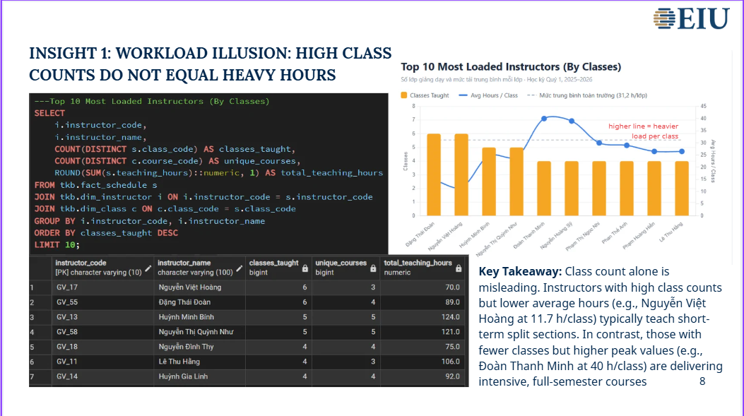
Figure 3. Top 8 most-loaded instructors by class count vs. average hours per class — the two metrics rank instructors differently.

5.2 Insight 2 — Chronic vs. Episodic Overload
Aggregating teaching hours by instructor and by term-week — and flagging any week at or above 14 hours (approximately the 95th percentile across all 712 instructor-week combinations) — surfaces four distinct overload patterns: chronic overload sustained across all ten weeks of the term, a severe but short-lived peak, load front-loaded into the first half of the term, and load back-loaded into the second half. Only the first pattern represents a genuine burnout risk requiring intervention; the other three are structural artifacts of how a course is scheduled, not evidence of an unsustainable workload. Distinguishing them requires weekly granularity — a term-total figure alone would misclassify all four patterns as equivalent.
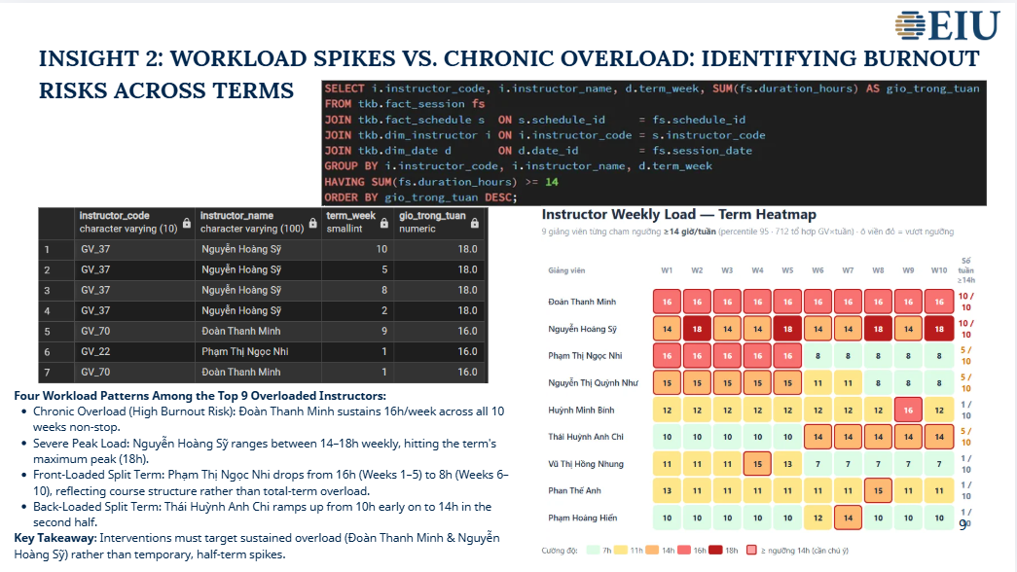
Figure 4. Instructor weekly-load heatmap across the ten weeks of the term, with the ≥14-hour threshold highlighted.

5.3 Insight 3 — Uneven Room Utilization
Room utilization was computed in two steps to avoid a common aggregation error: utilization percentage was first computed per individual room against a 550-hour-per-room availability baseline, and only then averaged by building. Averaging raw hours directly at the building level would understate utilization in buildings with more rooms and overstate it in buildings with fewer, since room count differs by building (e.g., 9 rooms in building B03 versus 1 in the BAMBOO building). The corrected calculation shows building B03 running at roughly 61% utilization while B08 and BAMBOO sit near 5–9%, a gap wide enough to support reallocating some shared-course lecture sections out of B03.
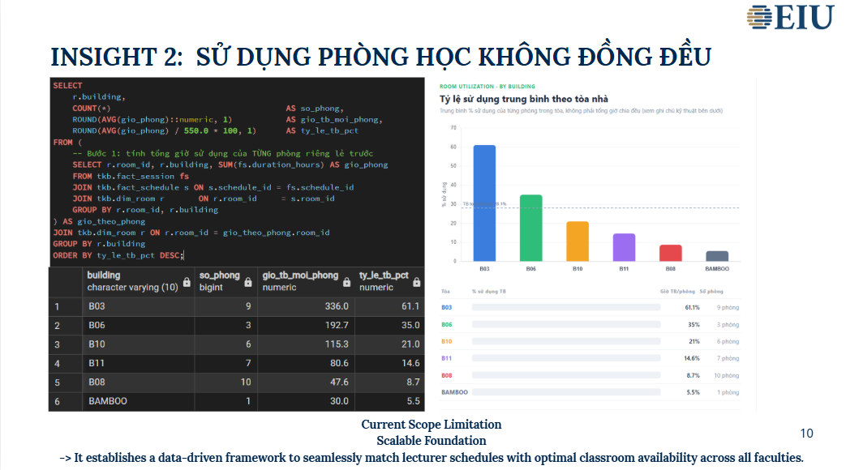
Figure 5. Average room-utilization rate by building, computed via per-room aggregation before building-level averaging.

5.4 Insight 4 — Automated Double-Booking Detection
A self-join on the session-level fact table (fact_session), joined back to the instructor and class dimensions and filtered on a standard time-overlap condition, checks every pair of sessions on the same date for the same instructor or the same room. Running this check against the full Quarter 1 dataset surfaced one genuine conflict: an instructor scheduled for two different class sections with only a 60-minute gap between an 11:30–13:30 session and a 10:30–12:30 session on the same day — an overlap that would not be visible from the flat spreadsheet without manually cross-referencing every row.
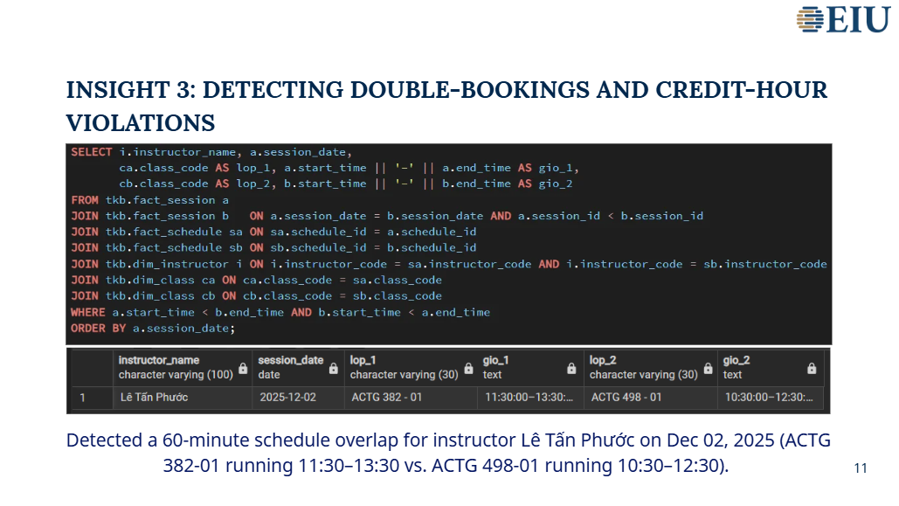
Figure 6. Detected instructor double-booking — a 60-minute schedule overlap on 2 December 2025.

6. Live Dashboard
To make the same findings accessible to non-technical stakeholders, the analysis was also implemented as a Google Apps Script web application bound to the source spreadsheet, organized into three tabs: an overview of headline counts and building-level hour distribution; an instructor workload matrix that classifies every instructor into one of four load categories (specialized/high-productivity, overloaded, spread-thin, or under-optimized) based on courses taught versus total hours; and a room-and-building utilization view that flags the most at-risk rooms and suggests specific rebalancing moves.
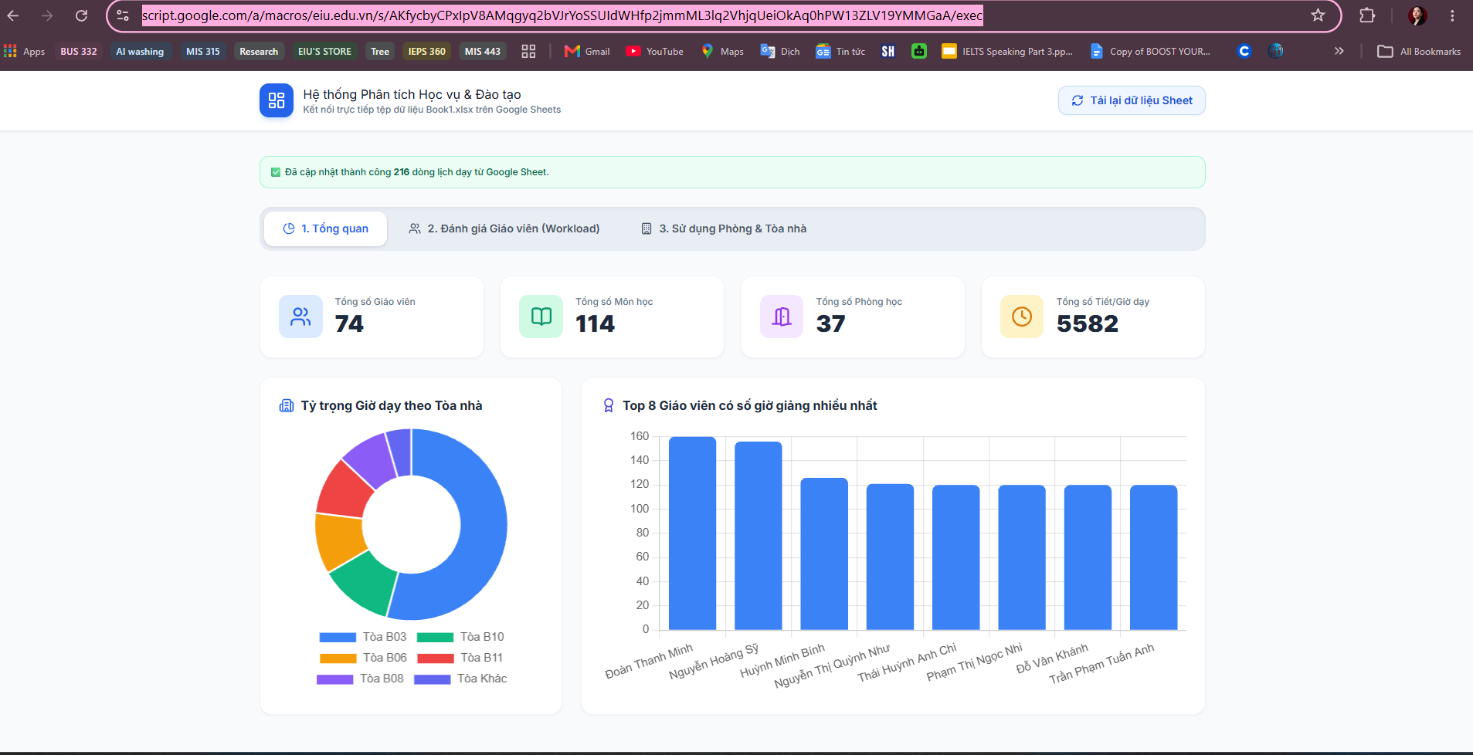
Figure 7. Dashboard — overview tab: headline counts, hours by building, and top instructors by load.
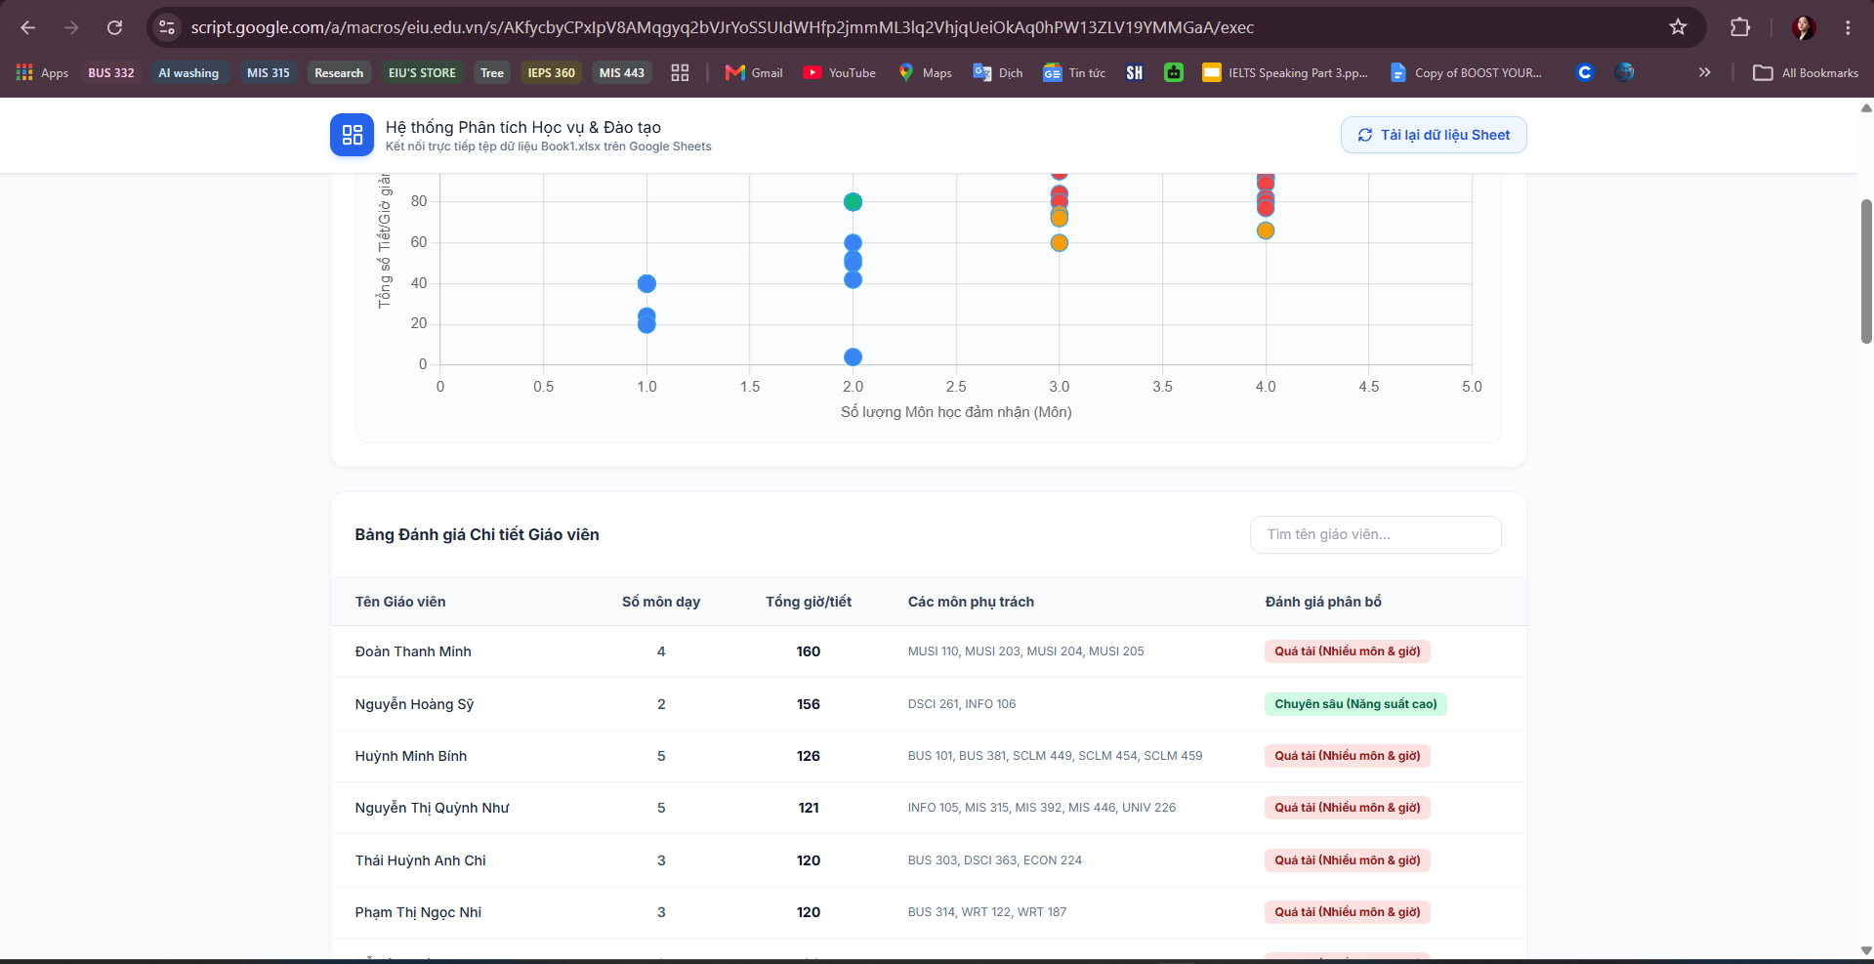
Figure 8. Dashboard — instructor workload matrix (courses taught × total teaching hours, four-category classification).
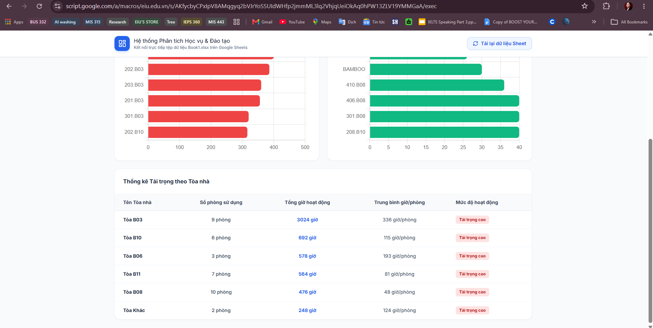
Figure 9. Dashboard — room and building utilization, with an automatically generated rebalancing suggestion.

7. Recommendations
- Establish weekly teaching-hour caps with an early-warning flag at peak weeks, using the term-week heatmap in Section 5.2 as the monitoring view.
- Rebalance lecture sections for shared, multi-section courses out of building B03 and into underused buildings (B08, BAMBOO), guided by the per-room utilization figures in Section 5.3.
- Run the credit-hour validation view (v_class_hours_check) and the double-booking self-join query as automated checks before a timetable is published, rather than discovering conflicts after the fact.

8. Limitations and Future Work
- The dataset covers a single quarter (Q1, 2025–2026); patterns described as "chronic" are chronic within this term only and have not been validated against prior terms.
- The double-booking check compares sessions within the loaded dataset only; it cannot detect conflicts with schedules outside this dataset (e.g., room bookings for non-class events).
- As discussed in Section 3.4, no text-based analytical technique (sentiment analysis, topic modeling) was applicable to this structured dataset; a natural extension once multi-term data is available would be a window-function-based ranking of instructor load by week (RANK() OVER (PARTITION BY term_week ORDER BY hours DESC)), which the current schema already supports without modification.

9. Conclusion
Re-modeling a single flat institutional spreadsheet as a validated PostgreSQL star schema turned a document that could only be read into one that could be queried. The resulting SQL analysis surfaced four insights — a workload-ranking illusion, the distinction between chronic and episodic instructor overload, an uneven room-utilization pattern across buildings, and a directly detected scheduling conflict — each of which supports a specific, low-cost operational recommendation for the registrar's office. Exposing the same validated data through both a reproducible, version-controlled repository and a live, non-technical dashboard demonstrates that rigorous data management and accessible business communication are not in tension: they can be built on exactly the same source of truth.

Appendix — Project Artifacts
- GitHub repository: github.com/NhuqDangg/MIS-443---Business-Data-Management/tree/main/MIS443_2032300287_ScheduleAnalytics
- Live dashboard: script.google.com/a/macros/eiu.edu.vn/s/AKfycbyCPxIpV8AMqgyq2bVJrYoSSUIdWHfp2jmmML3lq2VhjqUeiOkAq0hPW13ZLV19YMMGaA/exec
- SQL scripts: 01_create_table.sql (DDL), 02_import_data.sql (data load), 03_extract_data.sql (validation and analysis queries)
- Raw data: nine CSV files corresponding to the schema in Table 2

